**LAB-03**

**SQL queries using aggregate functions**

**Table:**

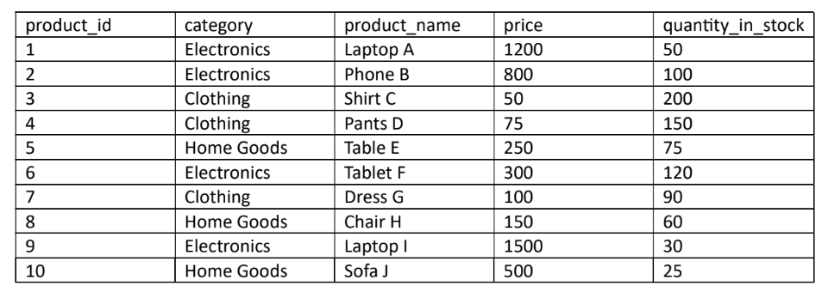

**Code:**

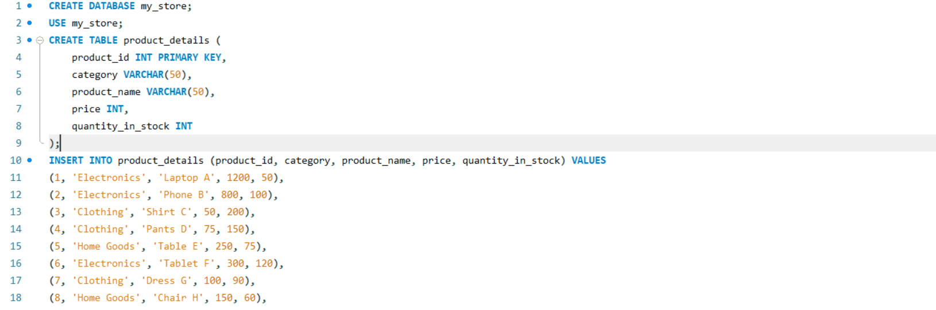

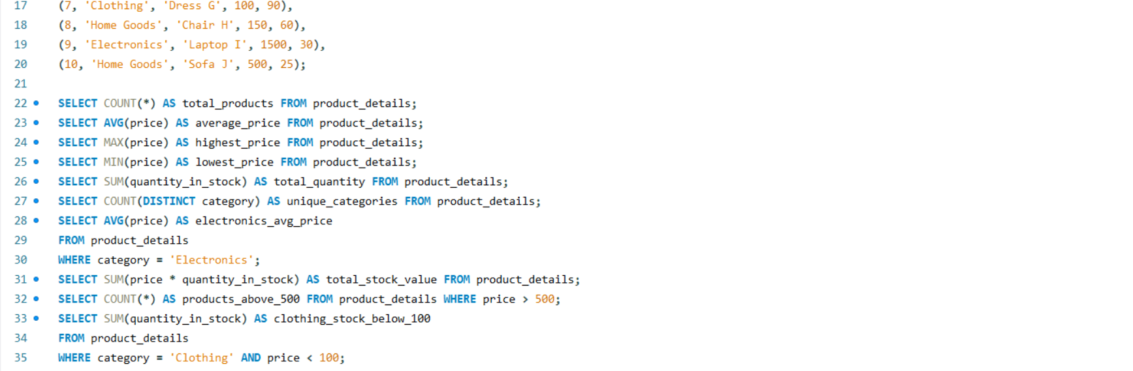

1.What is the total number of products in the table?

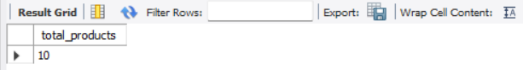

2. What is the average price of all products?



3. What is the highest price of any product?



4. What is the lowest price of any product?



5. What is the total quantity of all products in stock?



6. How many different categories of products are there?



7. What is the average price of products in the "Electronics" category?



8. What is the total value of all products in stock (price*quantity_in_stock)?



9. What is the number of products that have a price greater than 500?



10.What is the sum of the quantities in stock for products in the "Clothing"

category that cost less than 100?

